Beavers after School Hours (BASH)
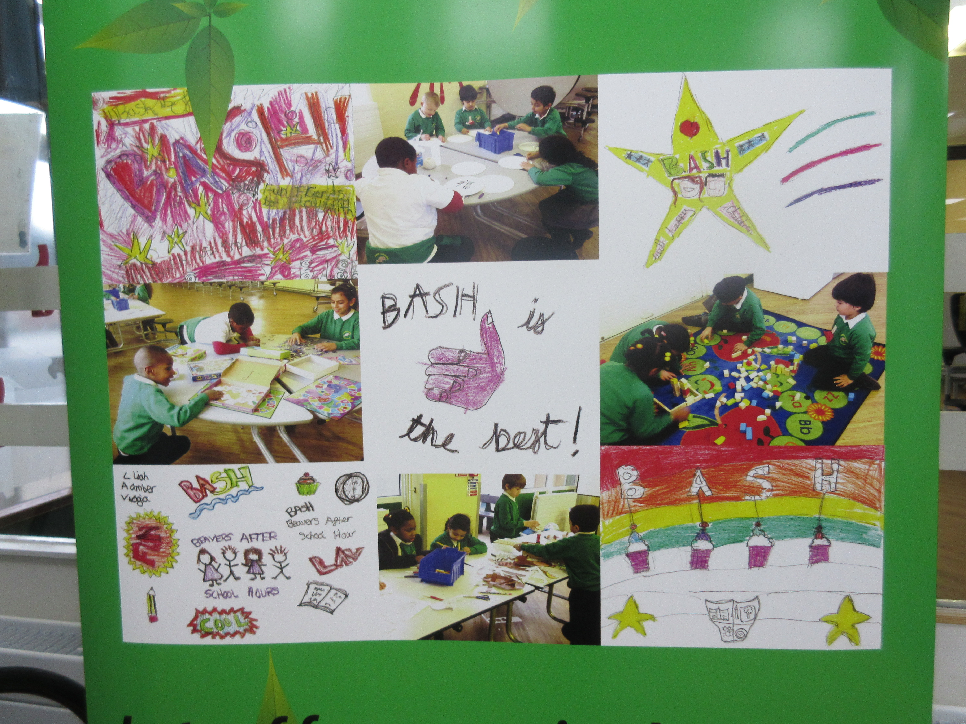
Extended Day Care Scheme
C/O
Beavers Community Primary School
Arundel Road
Hounslow
TW4 6HR
07933 623401

The scheme is here for you and your child’s benefit. We hope that you will find it of use and that your child enjoys coming.

The cost of the scheme is £7.50 per session (subject to review). £10.00 for a drop-in session. All sessions must be paid for regardless of whether or not your child attends BASH. No refunds will be given for sessions missed.

Payments must be paid on or before the first day of the week your child attends.

The session times are 3.15pm – 5.45pm.

Collection of children after this time will incur a late fee of £1.00 per minute till 6.00pm and £8.00 for every 5 minutes (or part thereof) after this time.

PLEASE NOTE: If any child is uncollected at the end of a session and no contact has been made by the parent/carer, then social services will be contacted.

We aim to provide a healthy, balanced snack with a dessert along with a drink throughout the session.

Should you have further questions then please do not hesitate to contact us on the above number during session times.

Regards

The BASH Team

BEAVERS AFTER SCHOOL HOURS (BASH)
Registration form
START DATE: ________________

CHILD NAME | GENDER: Male/Female
ETHNICITY: | MOTHER TONGUE:
DATE OF BIRTH: | AGE:
NAME OF PARENTS/CARERS (WITH PARENTAL RESPONSIBILITY):

HOME ADDRESS___________________________________________

_____________________________________________Post Code_________

Contact Telephone Number From 3.15PM To 6PM:

Mobile Number:
Email Address:
Name of Teacher: | Class:

Please circle day(s) your child attends:

Monday | Tuesday | Wednesday | Thursday | Friday

Name & Address of person other than above collecting your child:

Telephone Number:
Names of 1st Alternative contact (in case of emergency):

Relationship to Child:
Address:
Telephone number:

PLEASE TELL US OF ANY LEGAL REASON WHY ANYONE ELSE WHO HAS PARENTAL RESPONSIBILITY MAY NOT COLLECT YOUR CHILD (PROOF MUST BE SHOWN I.E. LETTER FROM COURT.

NAME of CHILD’S DOCTOR:

ADDRESS of CHILD’S DOCTOR:

MEDICAL TELEPHONE NUMBER:

(The details of the doctor will only be used to pass on to medical professionals in the event of an emergency)
Any known medical conditions, allergies, medication, etc.,

………………………………………………………………………………………………………………..

………………………………………………………………………………………………………………..

(If any medication is required on a regular basis e.g. an inhaler, please request a medicine administration form).
To help us provide the best possible care for your child, please inform us of any further information you feel staff should be aware of e.g. special needs, medication, equipment, support worker at school, statement, etc.

………………………………………………………………………………………………………………..

………………………………………………………………………………………………………………..

A snack will be provided. Please state below any allergies, religious/cultural requirements or any other preferences that may need to be taken into consideration:

………………………………………………………………………………………………………………..

………………………………………………………………………………………………………………..

In the event that my child requires immediate medical treatment and staff are unable to contact me/us, I hereby authorise the Play Leader or a delegated member of staff to seek medical advice and/or consent to emergency medical treatment on my behalf.

I understand that this authorisation will remain valid unless I contact the Play Leader to withdraw it.

I understand that every effort will be made to contact me/us. Members of staff cannot be held responsible for the decision made by medical professionals or their outcome, effects etc.

Signed………………………………………………………….Date ………………………………………..

Occasionally photographs may be taken in the scheme. Please sign below if you have no objection to these being used in publicity material for the scheme.

I give consent to photos of my child to be used as mentioned above.

Signed………………………………………………………….Date ………………………………………..

I/we hereby give my permission to allow BASH care scheme to exchange of information with the school/other professionals and carry out observation on my/our child to meet the EYFS legal requirements and support best practice.

I/we understand that observation and records will be available for inspection of Ofsted otherwise they will be treated as confidential. I/we understand that I/we are welcome to view any observations and records regarding our child at any time upon request.

Signed………………………………………………………….Date ………………………………………..

Any additional information you feel we should know.

……………………………………………………………………………………………………………………..

……………………………………………………………………………………………………………………..

……………………………………………………………………………………………………………………..

Thank you for your co-operation. All information given will be treated as confidential. Please remember to inform us immediately should any of this information change.
BEAVERS AFTER SCHOOL HOURS (BASH)
CONDITIONS OF MEMBERSHIP

Our responsibility to you

The scheme is here for you and your child’s benefit. We hope you find it of use and that your child enjoys coming to BASH. We would like to point out that this scheme is not officially part of the school, although it rents the premises from the school. The scheme is set up and runs as a voluntary organisation and as such it will need your help and support.

OPENING HOURS: 3.15pm to 5.45pm

COST: £7.50 PER SESSION (subject to review) or £10.00 per drop in session when spaces are available.

- We aim to provide your child with a safe, stimulating, caring environment and enable him/her to take part in a variety of leisure activities.

- The scheme will abide by the London Borough of Hounslow’s equal opportunity policy and no child will receive less favourable treatment than another on any grounds.

- No child will knowingly be allowed to leave the scheme mid-season unless collected by an authorised person aged over 16. For safety reasons your child must be signed out of the scheme each evening he/she attends by an authorised adult.

- Contact to the scheme must be made if the child is to be collected by any other adult other than the parent/carer.

- PLEASE NOTE: that if any child is uncollected at the end of a session and no contact has been made by parent/carer, Social Services will be contacted and the child handed over to their care. Where this is the case, information for the parent/carer will be left in a prominent place.

- It is important that you are aware that the scheme has a policy folder which is readily available for reading. Please ask the scheme’s Play Leader or a management committee member if you wish to read any of our policies.

Should you have any queries or problems, please do not hesitate to contact us, we may be able to help.

The committee reserves the right to withdraw the place of any child at its discretion.

BEAVERS AFTER SCHOOL HOURS (BASH)
YOUR RESPONSIBILITY TO US

I/WE THE PARENTS/CARERS OF…………………………………………………………………………………..……..

Wish to apply to use the facilities of BASH scheme and agree to the following terms and conditions:

- To collect my/our child/children from the aftercare scheme no later than 5.45pm. We understand that collection of children after this time will incur the following late collection charge per child: £1.00 per minute till 6.00pm and £8.00 for every 5 minutes (or part thereof) after this time. (These late collection charges cover the overtime costs for staff and caretaking, in addition to any fee).

- To pay punctually on the first day of the week that my child/children attend, the current fee per session for the week, in advance. We understand that this money is not refundable even if my/our child does not attend for any reason. This includes holidays, in respect of the borough policy, which does not allow for holidays to be taken during term time.

- That my/our child will attend on the days as confirmed at time of booking. Any changes of the days require two full weeks’ notice, is at the discretion of the Play Leader and according to space availability.

- That it is my/our responsibility to arrange for someone else over the age of 16 to collect my child on time should I/we be delayed for any reason.

- Contact to the scheme must be made if the child is to be collected by any other adult other than the parent/carer.

- If any child who remains uncollected and no contact has been made by parent/carer, Social Services will be contacted and the child handed over to their care.

- That it is my/our responsibility to ensure that the Play Leader is informed of any change of circumstances and/or problems, which occur so that they can be dealt with.

- To give two full weeks’ notice in writing should I/we wish to withdraw my/our child from the scheme.

- To keep the child away from the scheme if advised to do so by a doctor or by the Play Leader and to inform the scheme IMMEDIATELY if my/our child is absent due to a contagious disease.

- That it is my/our responsibility to ensure that my/our child understands that, whilst the scheme is more flexible than school, bad behaviour or behaviour that is either harmful to himself/herself/themselves, other children or equipment will not be acceptable.

Signed………………………………………………………….Date ………………………………………..

BASH PAYMENT DETAILS

Our Bank details are as follows:

Bank: Lloyds Bank
Account Name: BCPS Extended Day Care
Account Number: 00505316
Sort Code: 30-94-42

For your information:

The government have introduced a new incentive for parents to pay on line with the start of the new tax free childcare. Parents will be able to open a new childcare account. For every £8 a parent pays into their childcare account, the government will pay in extra £2. Parents can get up to £2000 government support per child per year towards childcare costs – that’s up to £500 every three months. This money can then be used to pay your childcare provider.

The government has started inviting parents to apply for Tax-Free Childcare beginning with parents of the youngest children first. Check whether Tax-Free Childcare is the best offer for you using the childcare calculator.

Parents will only be able to pay their childcare provider from their childcare account if their childcare provider is signed up to Tax-Free Childcare (BASH is signed up).

The link you will need to get more information and open an account is:
https://www.childcare-support.tax.service.gov.uk/par/applynow

If you have any further queries please do not hesitate to contact the BASH team.

